Dataset

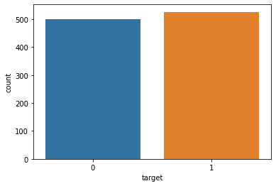

Results

Training Accuracy (KNN) : 84.61 %

Testing Accuracy (KNN) : 83.83 %

Classification report :

precision recall f1-score support

0 0.93 0.79 0.86 78

1 0.82 0.93 0.87 76

accuracy 0.86 154

macro avg 0.87 0.86 0.86 154

weighted avg 0.87 0.86 0.86 154

matplot

